**Installation**

1. Prerequisite

* Microsoft Visual Studio 2015 and above.
* .Net Framework 4.0

1. Download the source codes from https://github.com/yewmeng80/SEOAnalyser
2. Extract SEOAnalyser.zip and open SEOAnalyser.sln
3. Source codes loaded into Visual Studio.
4. Press F5 to build the source codes and website as below will be launched if build successfully.

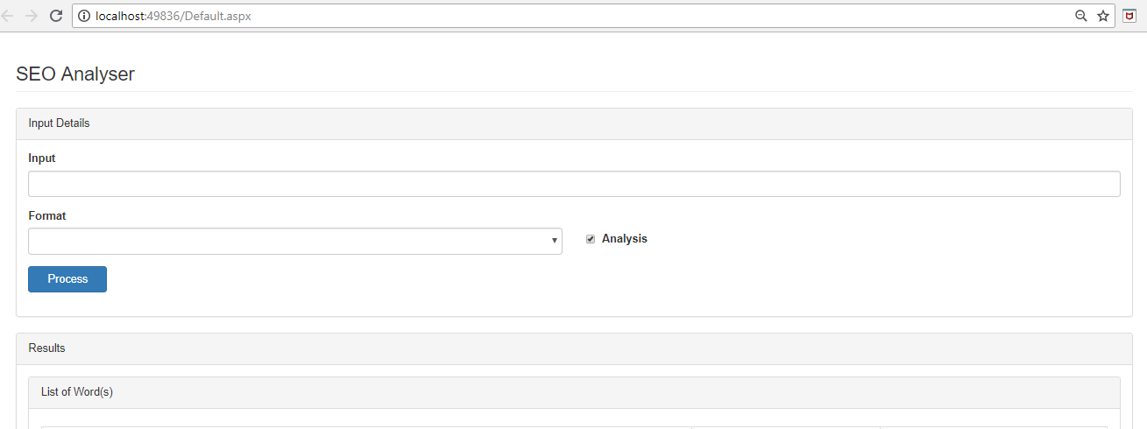

**User Guide**

**Analyze English Text**

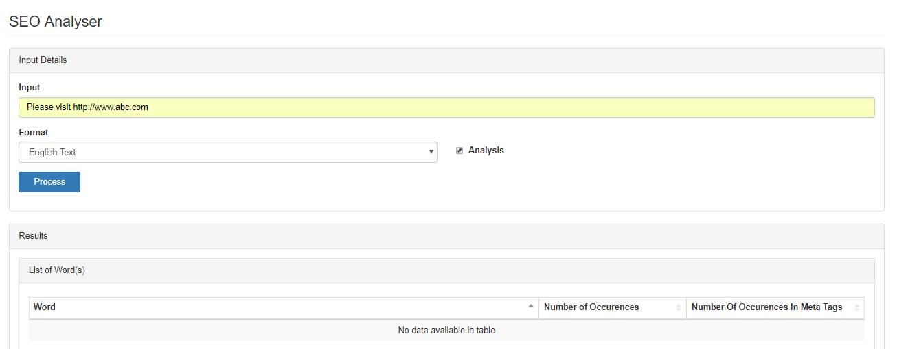

1. Input English text in Input Field and select English Text Format.
2. Check Analysis option to filter stop-words.
3. Click on button Process to analyze the input.
4. Results will be display at the “Results” section.

**Analyze URL**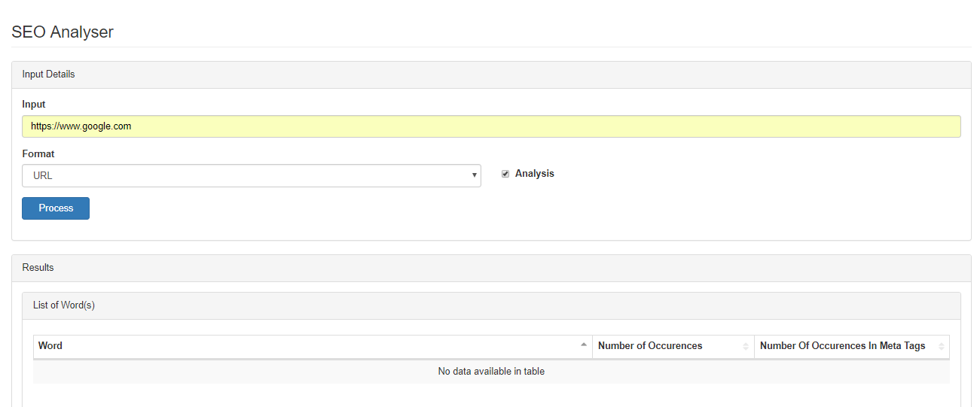

1. Input URL in Input Field and select URL Format.
2. Check Analysis option to filter stop-words.
3. Click on button Process to analyze the input.
4. Results will be display at the “Results” section.

**Troubleshooting**

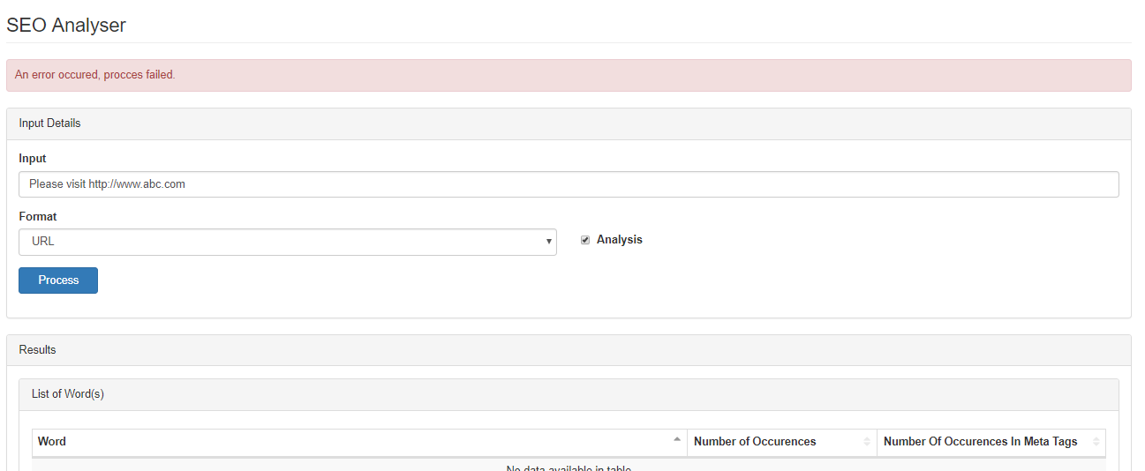

1. When the error message display as above, go to source code folder SEOAnalyser\SEOAnalyser\log to check the error details.